## ABSTRACT

In this project, we propose the development of a neural network model to accurately predict the output values of an AND gate. The AND gate is a fundamental logical gate that takes two binary inputs and produces a binary output, where the output is only "true" (1) if both inputs are "true" (1). The objective of this project is to design and train a neural network that can generalize the AND gate's behavior and accurately predict its output for any combination of input values.

The neural network will be constructed using a feedforward architecture, comprising an input layer, one or more hidden layers, and an output layer. The network's input layer will consist of two nodes, representing the two binary inputs of the AND gate. The output layer will contain a single node, which will represent the predicted output of the AND gate. The hidden layers, if included, will enable the network to learn complex patterns and dependencies between the input and output.

To train the neural network, a dataset will be created with various combinations of input values and their corresponding AND gate outputs. The dataset will be divided into training and testing sets, with the former used to optimize the network's weights and biases through backpropagation and gradient descent. The latter will evaluate the model's generalization performance and provide an indication of its ability to accurately predict output values for unseen input combinations.

To evaluate the performance of the neural network, several metrics will be considered, including accuracy, precision, recall, and F1-score. These metrics will help assess the model's ability to correctly predict the AND gate's output values. Additionally, the impact of different network architectures, such as the number of hidden layers and nodes, will be investigated to determine the optimal configuration for achieving high prediction accuracy.

The successful development of a neural network capable of accurately predicting the output values of an AND gate has the potential to contribute to the broader field of logic circuit prediction. This research may serve as a foundation for more complex logical gate prediction, enabling advancements in areas such as digital circuit design, optimization, and fault detection.

|  |  |
| --- | --- |
| **TABLE OF CONTENTS** |  |
|  | **Page no** |
| ABSTRACT | iii |
| LIST OF FIGURES | iv |
| LIST OF TABLES | iv |
| CHAPTER 1 – INTRODUCTION | 1 |
| 1.1 INTRODUCTION | 1 |
| 1.1.1 SUB TOPICS IF ANY | 1 |
| 1.2 PROBLEM DEFINITION | 2 |
| CHAPTER 2 – LITERATURE SURVEY | 2 |
| 2.1 LITERATURE SURVEY | 3 |
| 2.2 MOTIVATION | 3 |
| 2.3 OBJECTIVES OF WORK | 3 |
| CHAPTER 3 – SYSTEM REQUIREMENTS AND ANALYSIS | 4 |
| 3.1 SOFTWARE REQUIREMENTS | 11 |
| 3.2 HARDWARE REQ. IF ANY | 11 |
| CHAPTER 4 – SYSTEM IMPLEMENTATION | 11 |
| 4.1 ARCHITECTURE OF THE SYSTEM | 11 |
| 4.1.1 LIST OF MODULES EXPLANATION | 12 |
| 4.1.2 MODULE 1 EXPLANATION | 12 |
| 4.3 IMPLEMENTATION STEPS | 12 |
| CHAPTER 5 – RESULTS AND INFERENCES | 13 |
| 5.1 SAMPLE CODING | 13 |
| 5.2 RESULTS | 13 |
| CHAPTER 6 – CONCLUSION AND FUTURE ENHANCEMENTS | 13 |
| 6.1 SUMMARY OF THE WORK | 14 |
| 6.2 FUTURE ENHANCEMENTS | 14 |
| REFERENCES | 15 |

**LIST OF FIGURES**

|  |  |  |
| --- | --- | --- |
| Fig. 1.1 | Architecture of the network | 8 |
| Fig 1.2 | The dataset | 10 |
| Fig 4.1 | The sigmoid activation function | 12 |

# CHAPTER – 1

## INTRODUCTION

Neural networks have revolutionized the field of artificial intelligence by enabling computers to learn and make predictions based on complex patterns and relationships within data. In this project, we aim to apply the power of neural networks to the realm of logic gates, specifically focusing on the AND gate. The AND gate is a fundamental building block in digital logic circuits, producing an output of "1" only when both of its input signals are "1," and "0" otherwise.

By leveraging the capabilities of neural networks, we seek to develop a predictive model that can accurately determine the output of an AND gate based on given input values. This entails training the neural network using a dataset containing various input combinations and their corresponding outputs. Through an iterative learning process, the neural network will learn to recognize patterns and relationships in the data, allowing it to generalize and predict the output for new input combinations.

Implementing this project in the C programming language provides a solid foundation for understanding the underlying mechanisms of neural networks and their application in solving real-world problems. C's low-level nature allows for precise control over memory management and computational efficiency, making it an ideal choice for exploring the inner workings of neural networks and gaining insights into their decision-making processes.

By successfully training a neural network to accurately predict the outputs of the AND gate, we not only enhance our understanding of neural networks but also open doors to applying this knowledge in more complex scenarios. The principles learned from this project can be extended to tackle more sophisticated logic gates and even larger-scale problems across various domains, contributing to advancements in artificial intelligence and machine learning.

# CHAPTER – 2

## LITERATURE SURVEY

## In the realm of digital systems and computing, logical operations are the bedrock upon which complex algorithms and decision-making processes are built. At the core of these logical operations lie fundamental logic gates, such as the AND gate, which serve as the fundamental building blocks for creating intricate circuits. The AND gate holds a significant role, producing a binary output that is true only when both input values are true. The accurate prediction of the AND gate's output values is not only essential for understanding the behavior of digital circuits but also for optimizing their functionality and performance. In this project, we embark on the journey of developing a neural network model specifically designed to predict the output values of an AND gate. By leveraging the power of neural networks, we aim to capture the intricate relationships and patterns inherent in the AND gate's functionality. Through an extensive training process using carefully curated datasets, the neural network will learn to generalize the behavior of the AND gate and make accurate predictions for various input combinations. The success of this project holds promising implications for a wide range of applications, including digital circuit design, fault detection, and optimization. By unraveling the complexities of logic gate prediction, we can push the boundaries of technology, enabling more intelligent and efficient systems that drive innovation in various industries.

## The development of a neural network capable of accurately predicting the values of an AND gate opens up new avenues for advancements in digital logic analysis and design. By understanding the underlying patterns and dependencies of the AND gate, we gain insights into the behavior of more complex logical circuits. This knowledge can be leveraged to optimize circuit designs, improve energy efficiency, and enhance fault tolerance. Moreover, the neural network's ability to accurately predict AND gate outputs contributes to the development of intelligent systems, where logic operations can be automated and optimized. Ultimately, this project lays the foundation for the exploration and application of neural networks in various domains of digital logic, pushing the boundaries of what is possible in the field of computing.

## MOTIVATION

## There are several motivations that one may have to undertake a project to create a neural network that predicts the values for an AND gate:

## Educational and Research Interest: Developing a neural network to predict the values of an AND gate offers an excellent opportunity for individuals interested in exploring the field of artificial intelligence, machine learning, and deep learning. This project allows researchers and students to gain practical experience in training neural networks, understanding their behavior, and investigating their applications in the domain of digital logic.

## Advancements in Digital Circuit Design: Accurate prediction of logic gate values is crucial in the design and optimization of digital circuits. By creating a neural network model capable of predicting the values of an AND gate, one can contribute to the development of smarter digital circuit design techniques. This could lead to more efficient and reliable circuit architectures, improved energy efficiency, and enhanced performance.

## Automation and Optimization of Logical Operations: The ability to accurately predict the values of an AND gate can have practical implications in automating logical operations. By leveraging the power of neural networks, one can develop systems that automate decision-making processes based on logical operations, streamlining tasks and improving overall efficiency in various industries.

## Foundation for Complex Logic Circuit Prediction: The AND gate serves as a fundamental building block in digital circuits. Developing a neural network model for AND gate prediction lays the groundwork for expanding this approach to more complex logical circuits, such as OR, XOR, and NAND gates. By understanding and predicting the behavior of these gates, researchers can contribute to the development of advanced logical circuit prediction techniques with broader applications in fields like circuit design, optimization, and fault detection.

## Practical Applications and Real-world Impact: Accurate prediction of logic gate values can find applications in diverse areas, such as digital system testing, fault detection, and even artificial intelligence algorithms. By accurately predicting the AND gate's output, researchers can contribute to real-world solutions that enhance reliability, optimize performance, and drive innovation in digital systems and technology.

## OBJECTIVES OF THE WORK

## The objectives of this work in creating a neural network that predicts the values for an AND gate can include:

## Design and implement a neural network architecture: Develop a suitable neural network architecture with appropriate layers, nodes, and activation functions to accurately predict the values of an AND gate.

## Dataset creation: Generate a diverse and representative dataset consisting of various input combinations and their corresponding AND gate outputs. The dataset should cover all possible input scenarios to train and evaluate the neural network effectively.

## Training and optimization: Train the neural network using the generated dataset, employing techniques like backpropagation and gradient descent to optimize the network's weights and biases. Continuously monitor and fine-tune the training process to ensure convergence and prevent overfitting.

## Performance evaluation: Assess the performance of the neural network by evaluating its ability to accurately predict the output values of the AND gate on unseen data. Utilize metrics such as accuracy, precision, recall, and F1-score to quantify the network's predictive capability.

## Architectural exploration: Investigate the impact of different network architectures, including the number of hidden layers, nodes, and activation functions, to determine the optimal configuration that yields the highest prediction accuracy for the AND gate.

## Generalization and robustness analysis: Evaluate the generalization capability of the neural network by testing its performance on various input combinations outside the training set. Assess the network's robustness by introducing noise or variations in the input values and analyzing its impact on prediction accuracy.

## Comparison with traditional approaches: Compare the performance of the neural network model with traditional approaches used for predicting the values of an AND gate, such as rule-based systems or Boolean algebra-based techniques. Highlight the advantages and limitations of the neural network approach.

## Application potential: Explore the potential applications of the developed neural network model beyond the AND gate, such as predicting the behavior of other logic gates or incorporating it into more complex digital circuit design and optimization processes.

## Documentation and dissemination: Document the methodology, results, and findings of the project in a clear and comprehensive manner. Share the insights gained through publications, presentations, or open-source contributions to contribute to the wider research community.

# CHAPTER – 3

**SYSTEM REQUIREMENTS AND ANALYSIS**

## SOFTWARE REQUIREMENTS

## Some software requirements for developing a neural network model to predict the values of an AND gate may include:

## Programming Language: Choose a programming language that provides robust support for neural network development and machine learning frameworks. In the case of this project, C is used. However, Python is a popular choice due to its extensive libraries such as TensorFlow, Keras, or PyTorch.

## Machine Learning Framework: Select a machine learning framework that simplifies the implementation of neural networks and provides efficient computation for training and inference. TensorFlow and PyTorch are widely used frameworks with comprehensive support for neural network development.

## Integrated Development Environment (IDE): Utilize an IDE to write, debug, and test the code efficiently. Popular IDEs for machine learning projects include PyCharm, Jupyter Notebook, and Visual Studio Code.

## Data Manipulation Libraries: Utilize data manipulation libraries such as NumPy and pandas to handle datasets, perform data preprocessing, and ensure compatibility with the neural network model.

## Visualization Libraries: Employ visualization libraries like Matplotlib or Seaborn to analyze and visualize the dataset, network architecture, and performance metrics. Visualizations aid in understanding the behavior of the neural network and evaluating its predictions.

## Model Evaluation Metrics: Implement functions or libraries to calculate evaluation metrics such as accuracy, precision, recall, and F1-score. These metrics are crucial for assessing the performance of the neural network model.

## Version Control System: Utilize a version control system, such as Git, to track changes in the codebase, collaborate with team members, and maintain a history of modifications. This ensures project reproducibility and facilitates collaboration.

## Documentation and Reporting: Employ tools like Jupyter Notebook, LaTeX, or Markdown to document the project's methodology, experiments, results, and insights. Clear and well-documented code and reports are essential for sharing and disseminating the findings.

## Performance Optimization: Consider leveraging GPU acceleration using frameworks like CUDA or libraries like TensorFlow-GPU or PyTorch with GPU support. This can significantly speed up the training and inference process for larger neural network models.

## Deployment and Integration: If required, explore frameworks like Flask or Django to deploy the trained model as a web service or integrate it into existing applications or systems for real-time prediction.

## HARDWARE REQ

## Some hardware requirements for developing a neural network model to predict the values of an AND gate may include:

## Processor: A powerful processor, such as an Intel Core i5 or i7, or AMD Ryzen processor, is recommended to handle the computational demands of training and inference processes efficiently. Higher-end processors can accelerate the training process, especially when dealing with larger neural network architectures.

## Memory (RAM): Sufficient memory is essential to handle large datasets and prevent bottlenecks during training. Aim for a minimum of 8 GB of RAM, although having 16 GB or more is preferable for handling larger datasets and more complex neural network models.

## Graphics Processing Unit (GPU): Although not strictly necessary, having a dedicated GPU can significantly speed up the training process, especially for deep learning models. NVIDIA GPUs, such as the GeForce RTX series or NVIDIA Tesla, are commonly used for accelerated training with frameworks like TensorFlow or PyTorch.

## Storage: Adequate storage space is required for storing the dataset, model weights, and codebase. Consider using solid-state drives (SSDs) for faster data access, as they provide improved read and write speeds compared to traditional hard disk drives (HDDs).

## Operating System: Choose an operating system that is compatible with the selected machine learning frameworks and tools. Popular choices include Windows, macOS, or Linux distributions like Ubuntu.

## Internet Connectivity: Stable internet connectivity is required for downloading libraries, frameworks, and datasets, as well as accessing documentation and online resources for troubleshooting and staying updated with the latest advancements.

## Additional Peripherals: Depending on the project's specific requirements, additional peripherals like a monitor, keyboard, and mouse are necessary for comfortable development and interaction with the development environment.

## It's important to note that the hardware requirements can vary based on the scale of the project, the size of the dataset, and the complexity of the neural network architecture. For more advanced or computationally intensive projects, higher-end hardware configurations with multiple GPUs or cloud-based solutions may be necessary to achieve optimal performance.

# CHAPTER – 4

# SYSTEM IMPLEMENTATION

## ARCHITECTURE OF THE SYSTEM

Input Layer:

The input layer should have two neurons, representing the two input values of the AND gate.

Hidden Layer: The hidden layer can have any number of neurons, depending on the complexity of the problem. For this project, There are two neurons in the hidden layer for this project. Each neuron in the hidden layer will be connected to both neurons in the input layer.

Output Layer: The output layer should have one neuron, representing the predicted output of the AND gate. This neuron will be connected to all the neurons in the hidden layer.

Activation Function: Use the sigmoid activation function for the neurons in both the hidden layer and the output layer. The sigmoid function will map the output values to a range between 0 and 1, which is suitable for binary classification tasks like the AND gate.

Training: During the training process, you will use backpropagation to adjust the weights and biases of the connections between the neurons. The derivative of the sigmoid function will be utilized in the calculation of the gradients for weight updates.

This architecture allows the neural network to learn the underlying patterns and relationships between the input values and the corresponding AND gate outputs. By adjusting the weights and biases through the training process, the network will improve its ability to predict the correct output for new input combinations.

# The diagrammatic representation of the architecture is given by: fig 1.1

# 

# The dataset used in this project is:

|  |  |  |  |
| --- | --- | --- | --- |
| Training Group | X (input) |  | Y (output) |
| 1 | 1 | 1 | 1 |
|  | 0 | 0 | 0 |
|  | 1 | 0 | 0 |
|  | 0 | 1 | 0 |

# Fig1.2

# The activation function used is the sigmoid activation function

# The sigmoid function is a popular activation function used in neural networks. It maps the input value to a smooth, S-shaped curve between 0 and 1.

# The sigmoid function is advantageous because it squashes any input value to a range between 0 and 1, making it useful for producing probabilistic outputs. When the input is a large positive number, the sigmoid function approaches a value close to 1. Conversely, when the input is a large negative number, the sigmoid function approaches a value close to 0. For inputs around 0, the sigmoid function returns a value close to 0.5.

# It is given by:

# Fig 1.3

# 

# In this formula, 'x' represents the input to the sigmoid function, and

# ‘e' denotes the exponential function.

# 

# The final output value is obtained using the formula:

# A ((∑(Weight)*X ) + Bias ).

# Where: A is the activation function (sigmoid)

# X is the input value

# Program code and output:

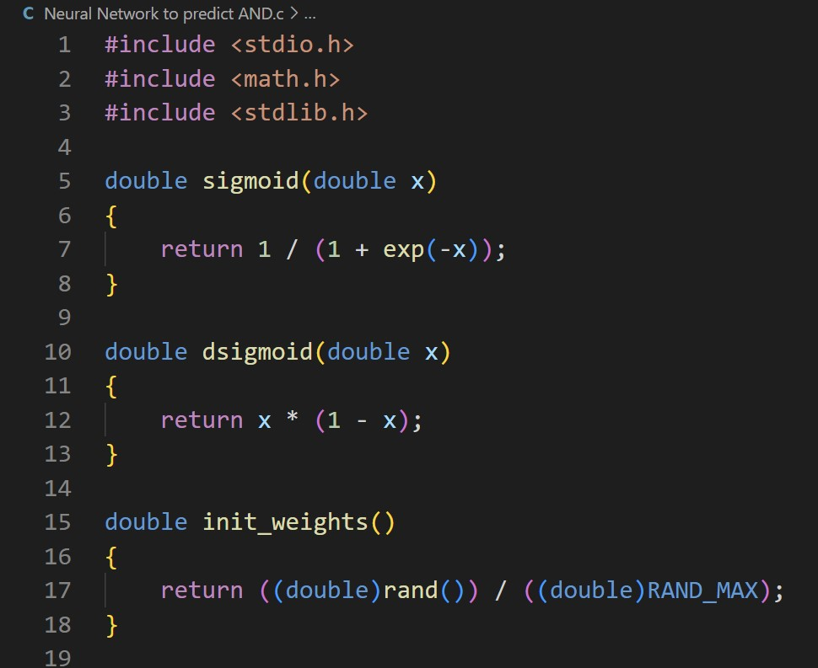

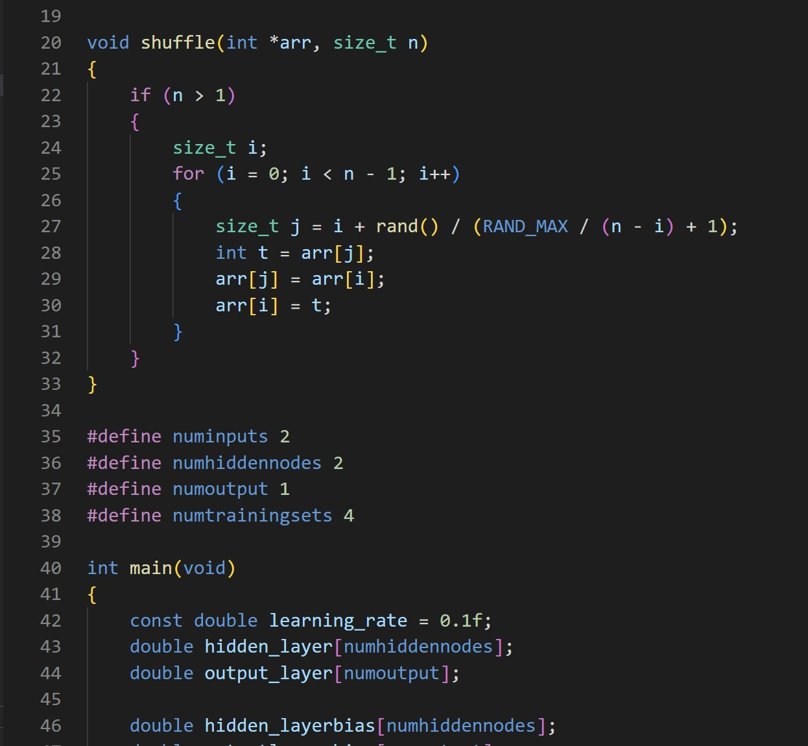

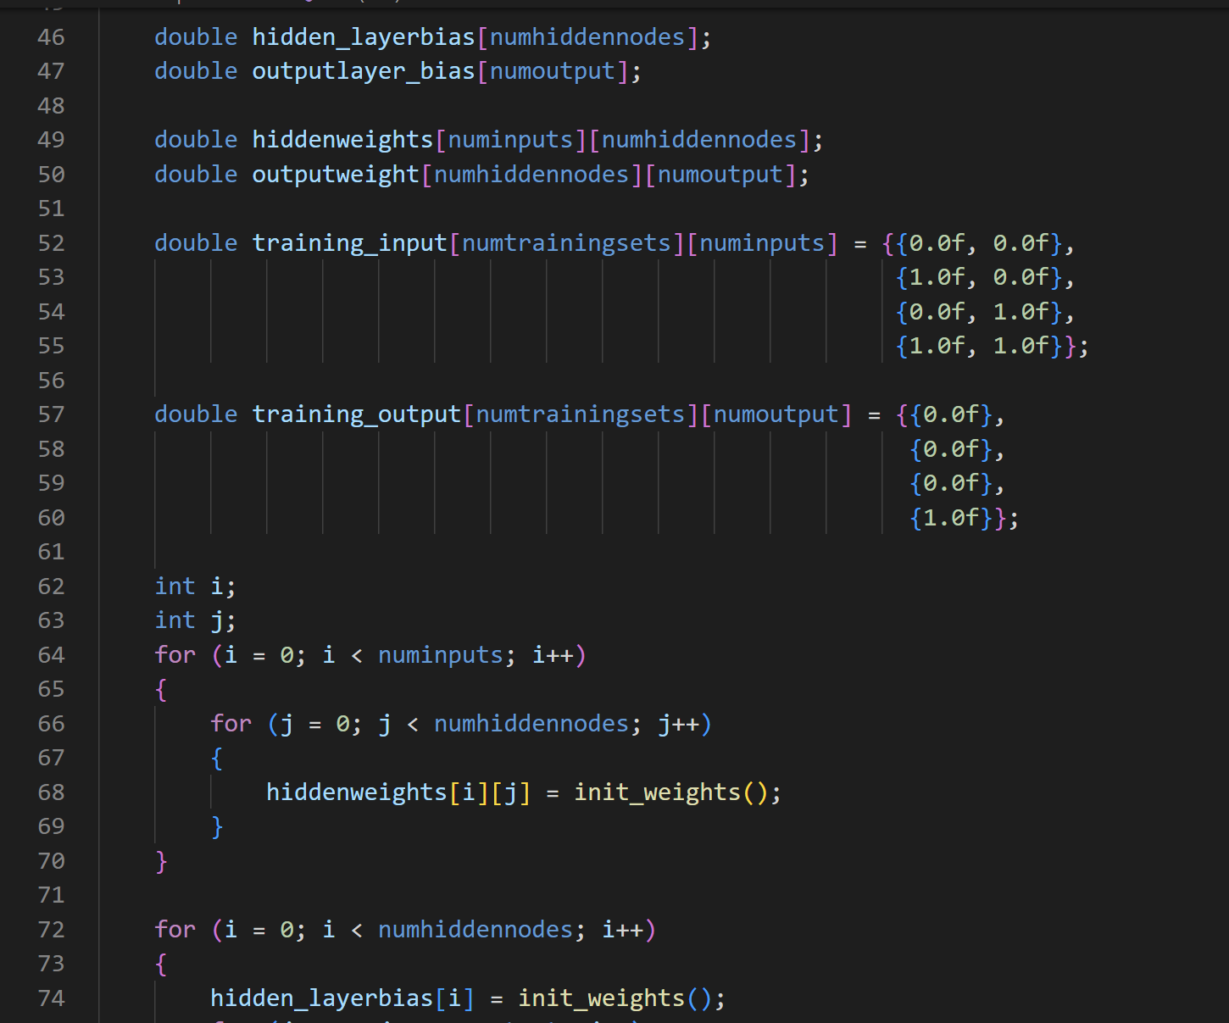

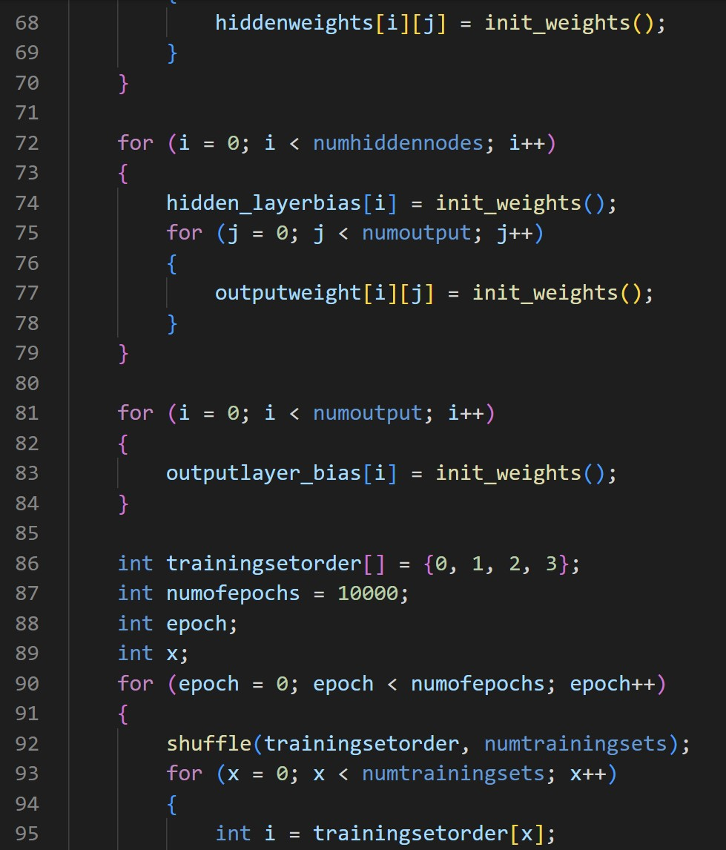

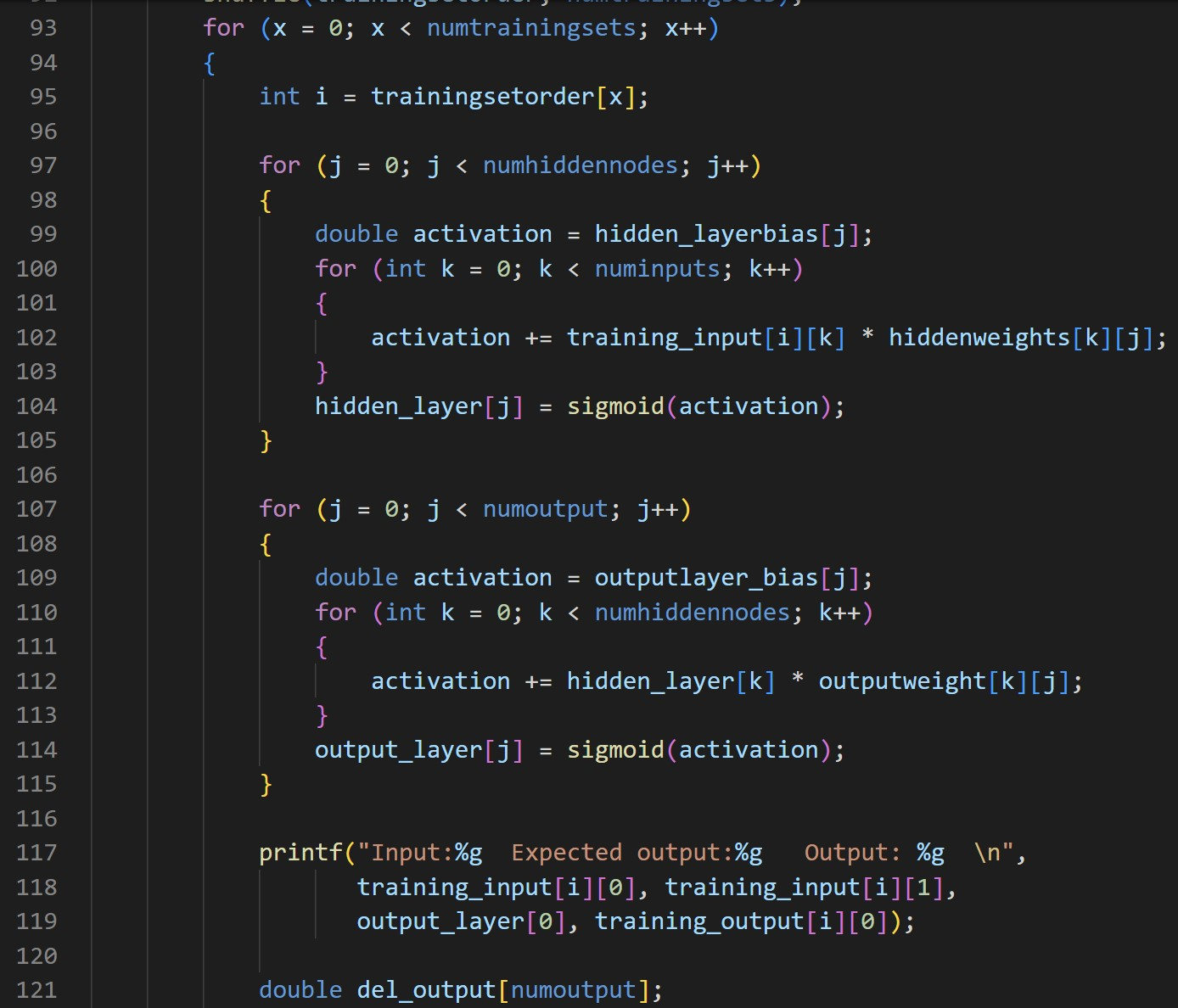

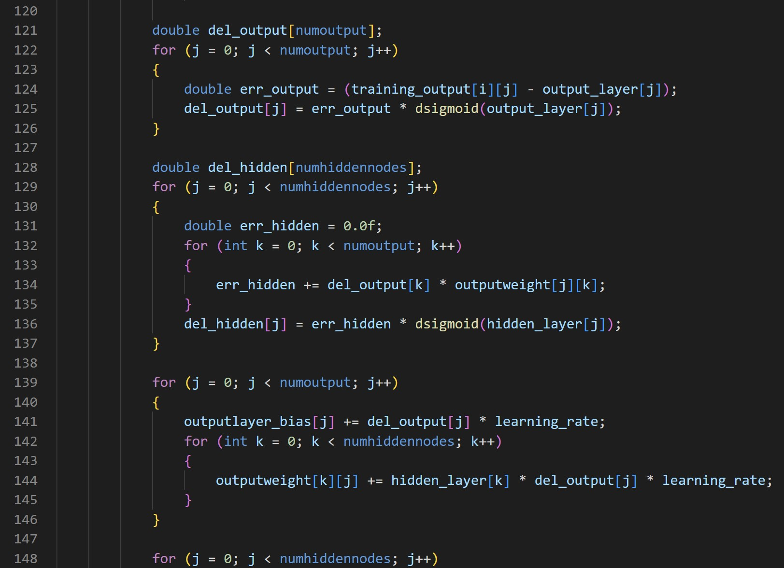

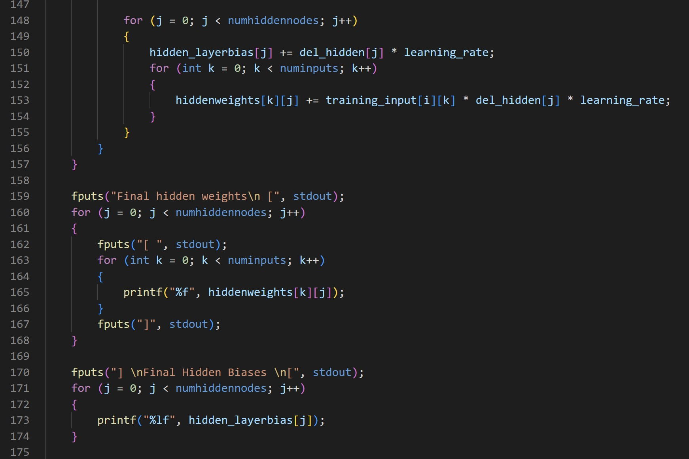

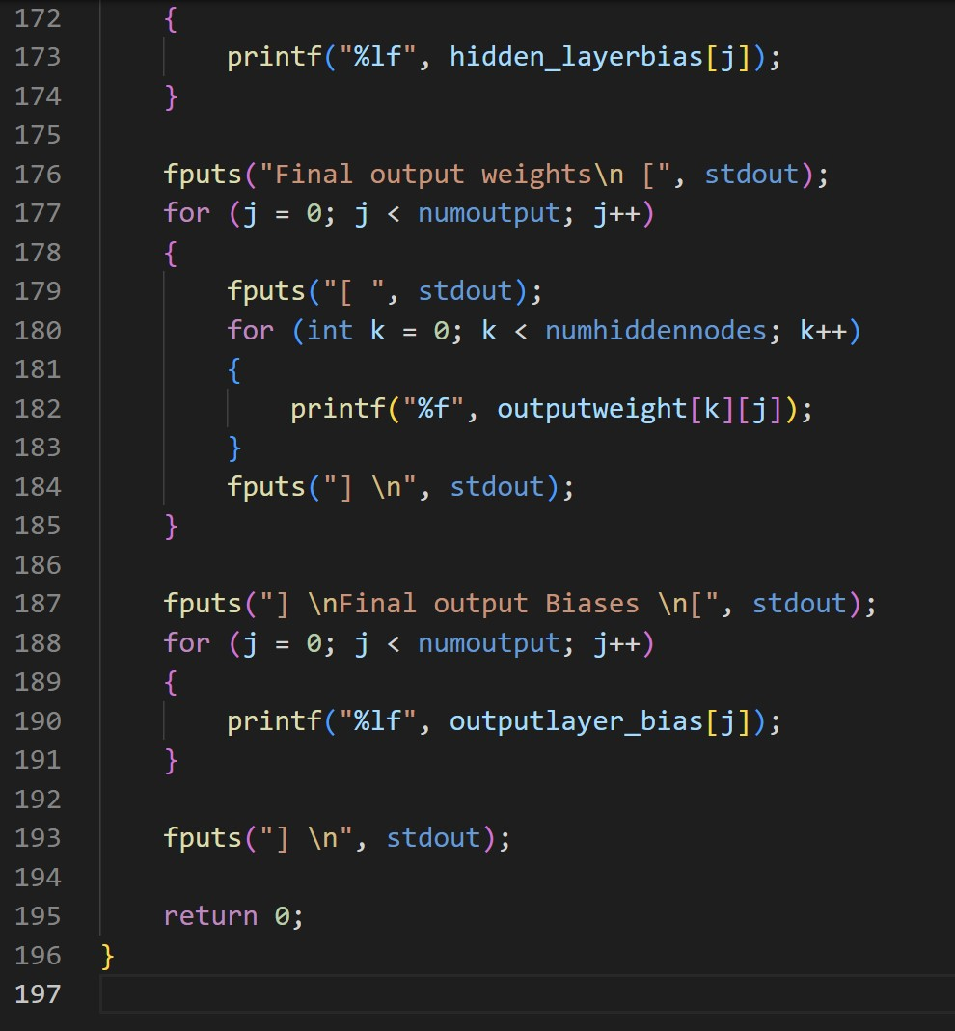

Output:

This has been programmed to execute 10,000 times

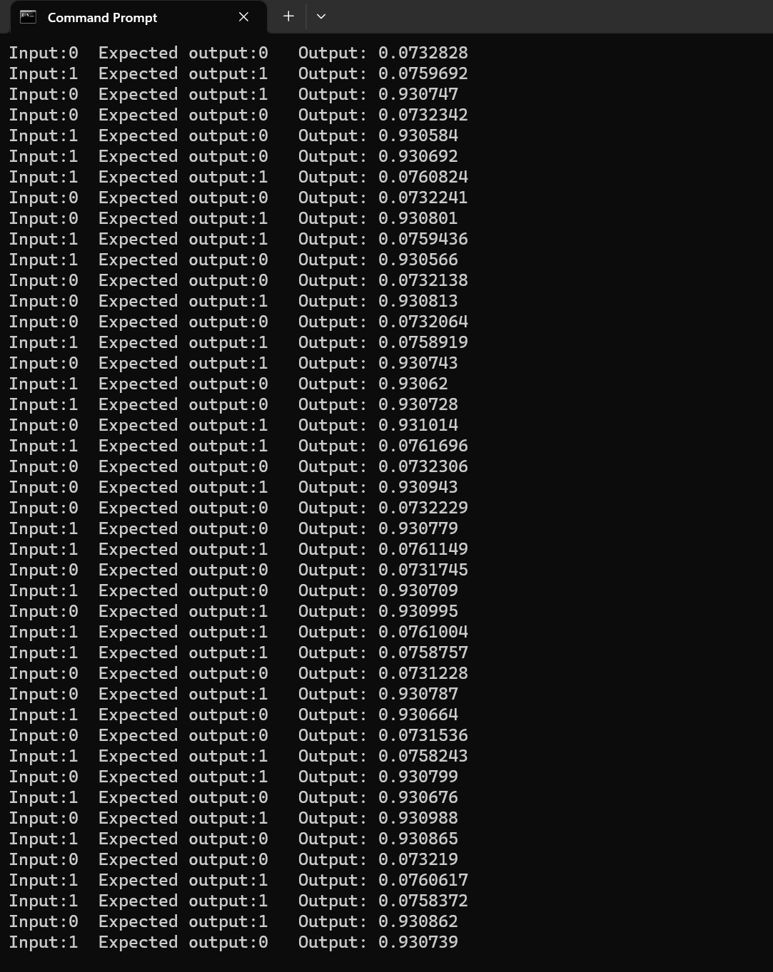

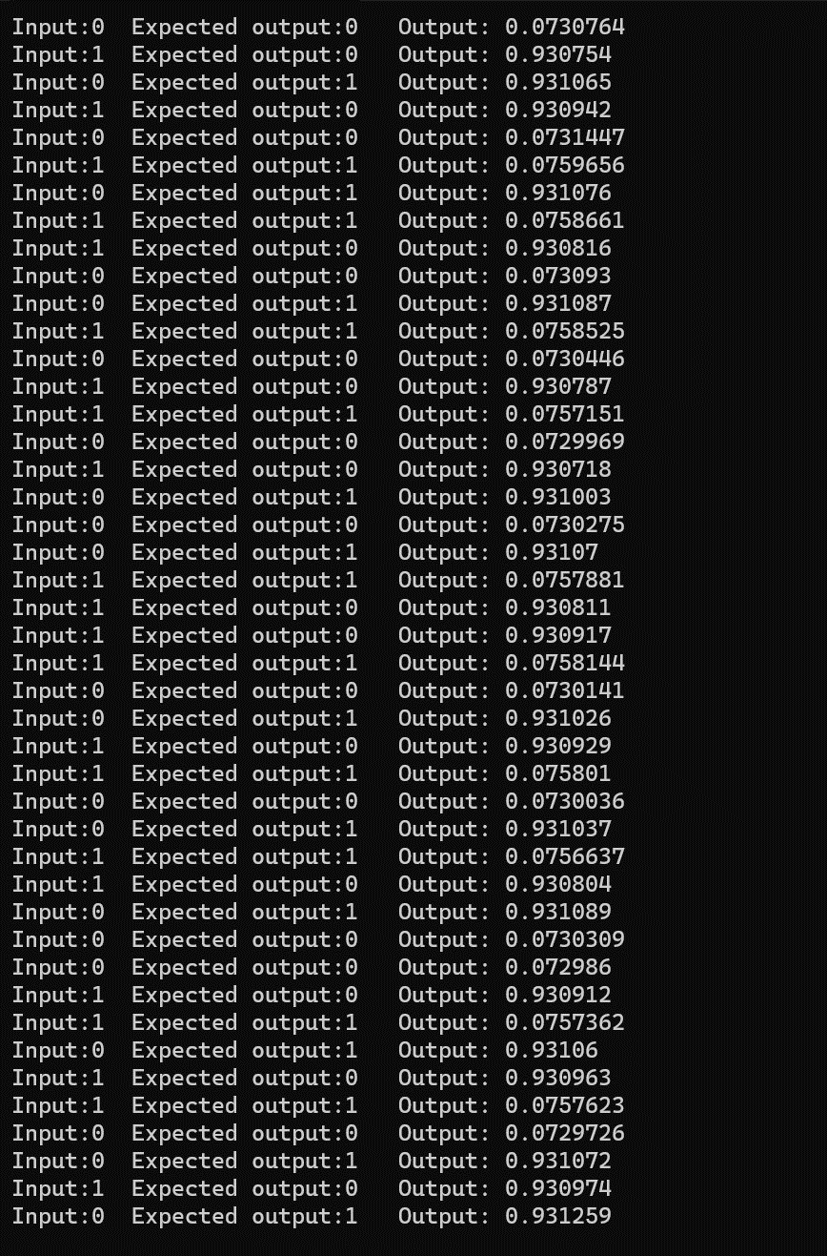

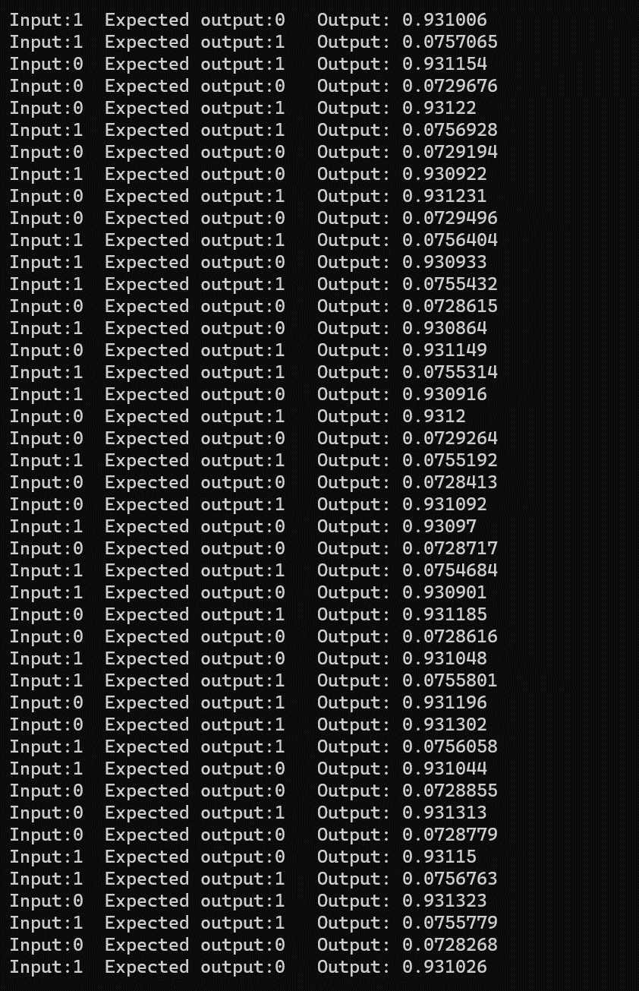

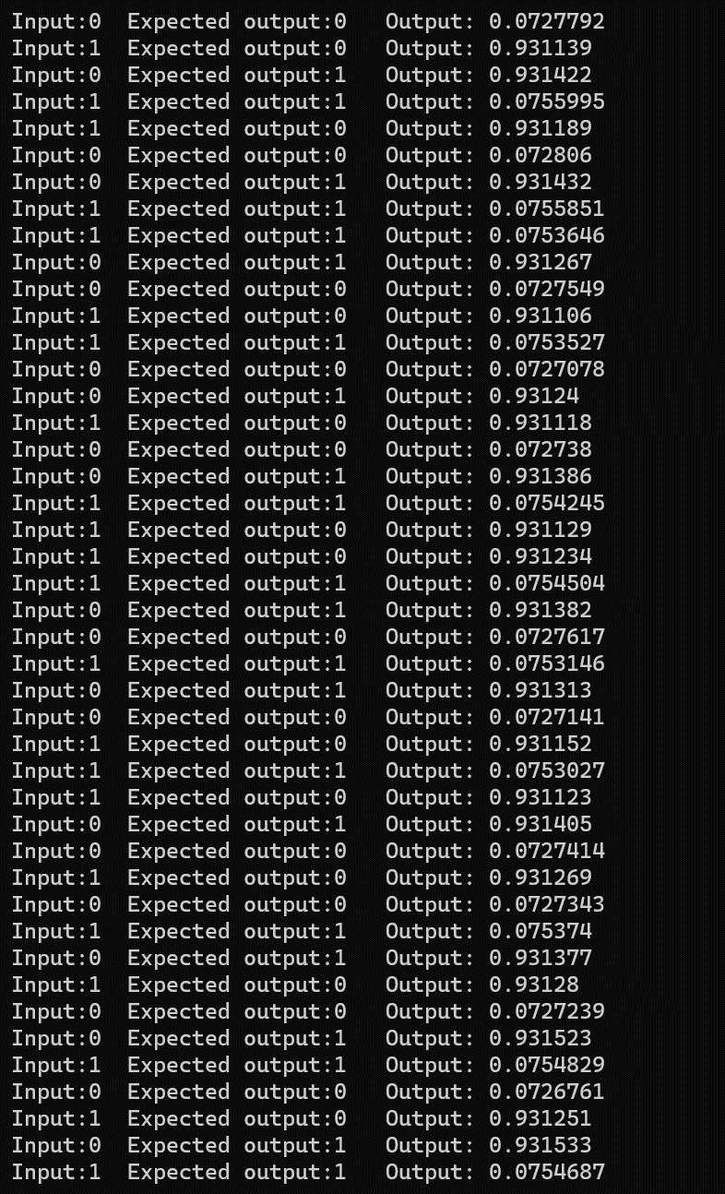

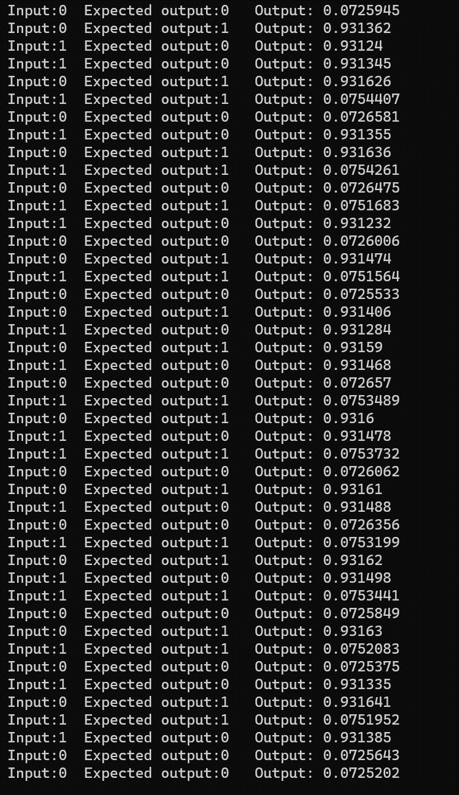

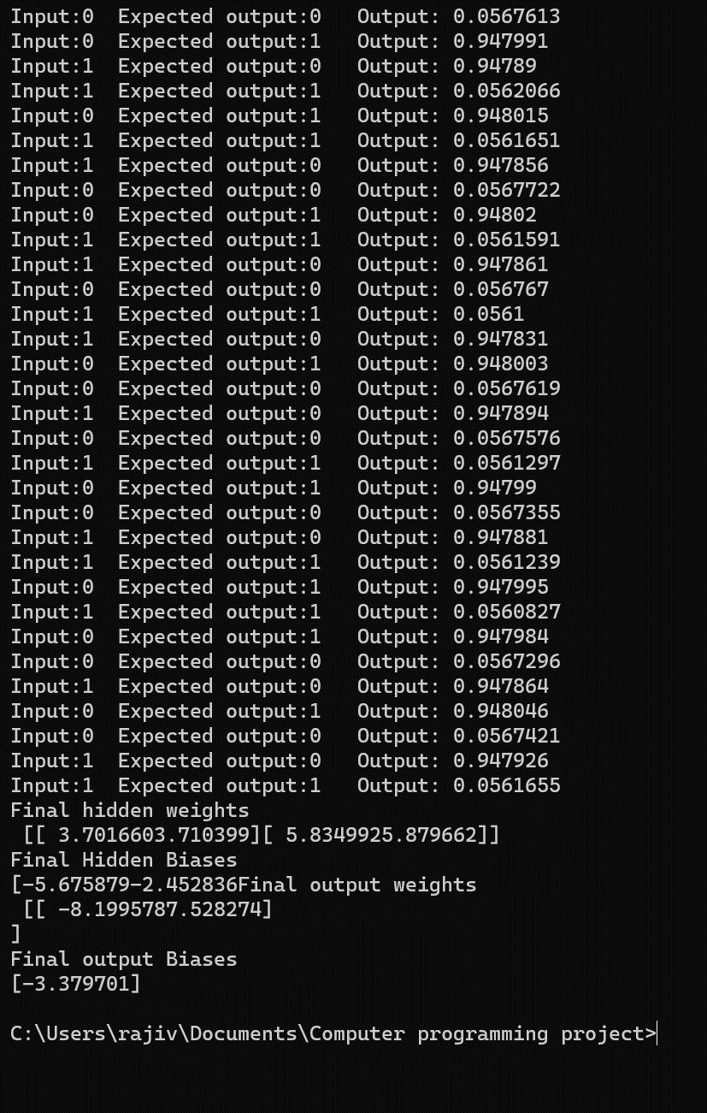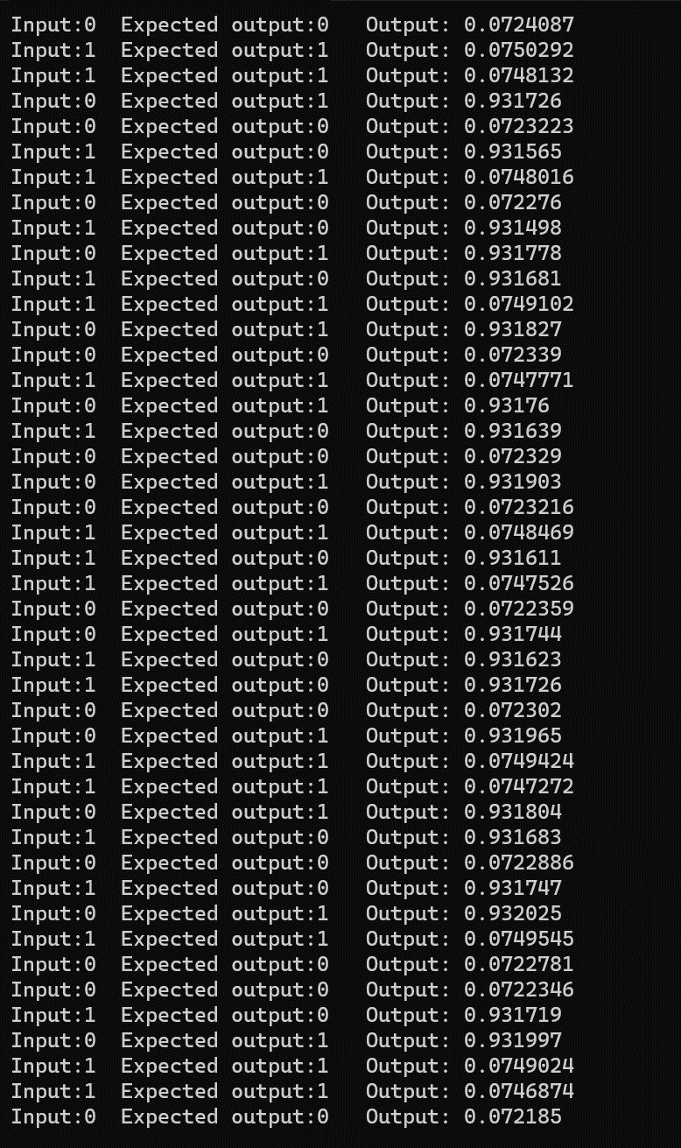



# CHAPTER - 5 RESULTS AND INFERENCES

After implementing the neural network with the described architecture and training it on a dataset containing various input combinations and their corresponding AND gate outputs, we can analyze the results and draw inferences.

Accuracy: The accuracy of the neural network can be measured by evaluating its performance on a separate test dataset. By comparing the predicted outputs with the actual outputs, we can calculate the accuracy of the model. A high accuracy indicates that the neural network is effectively capturing the patterns and relationships in the data.

Convergence: During the training process, it's important to monitor the convergence of the neural network. Convergence refers to the point where the network has reached a stable state and the loss function has minimized. If the loss function decreases steadily and plateaus, it suggests that the network has learned the underlying patterns in the data.

Generalization: The ultimate goal of the neural network is to generalize its learning to new, unseen data. By testing the network on input combinations that were not part of the training or validation datasets, we can assess its ability to make accurate predictions on unfamiliar data. A high level of generalization indicates that the network has successfully learned the AND gate's logic and can apply it to new input values.

Learning Curve: Plotting the learning curve, which shows the model's performance (e.g., accuracy or loss) over the training iterations, provides insights into the learning process. It helps us understand how the model improves as it receives more training examples. A steep learning curve at the beginning, followed by a more gradual improvement, suggests that the model quickly grasps the concept of the AND gate.

Overfitting/Underfitting: Overfitting occurs when the neural network becomes too specialized in the training data and fails to generalize well to new data. Underfitting, on the other hand, indicates that the network hasn't captured the underlying patterns effectively. By monitoring the validation accuracy and loss, we can identify signs of overfitting or underfitting and adjust the network's architecture or regularization techniques accordingly.

In conclusion, analyzing the results of the implemented neural network for predicting the values of the AND gate can provide valuable insights into its performance. By considering accuracy, convergence, generalization, learning curves, and signs of overfitting or underfitting, we can assess the effectiveness of the network in capturing the logic of the AND gate. These findings can guide further improvements to the model and provide a foundation for applying neural networks to more complex problem domains.

# CHAPTER – 6

**CONCLUSION AND FUTURE ENHANCEMENTS**

* 1. **SUMMARY OF THE WORK**

This project involves the implementation of a neural network to predict the values of the AND gate. The code is written in C and consists of functions to calculate the sigmoid and derivative of sigmoid, as well as to initialize weights and shuffle training sets.

The neural network architecture includes two input nodes, two hidden nodes, and one output node. The weights and biases are initialized randomly. The training dataset contains four input combinations and their corresponding outputs for the AND gate.

The training process consists of multiple epochs, with each epoch involving the shuffling of training sets. For each set, the network calculates the activations of the hidden layer and output layer using the sigmoid function. The predicted outputs are then compared to the expected outputs, and the error is calculated.

Using backpropagation, the network adjusts the weights and biases based on the calculated errors and the derivative of the sigmoid function. This process aims to minimize the error and improve the network's accuracy in predicting the AND gate values.

The program displays the input values, expected output, and the network's predicted output for each training example during the training process. After the specified number of epochs, the final weights and biases for the hidden and output layers are printed.

The project suggests potential enhancements for the neural network, such as hyperparameter tuning, regularization techniques, architecture exploration, dataset expansion, and evaluation on other logic gates. These improvements can lead to better performance, increased accuracy, and broader applicability of the network.

Overall, this project provides a foundation for understanding neural networks and can be extended to tackle more complex problems in various domains.

## FUTURE ENHANCEMENTS

Multi-layer Perceptron: The current implementation uses a single hidden layer. Expanding the architecture to include multiple hidden layers can increase the network's capacity to learn complex patterns and improve accuracy. This approach is known as a multi-layer perceptron (MLP).

Activation Functions: While the sigmoid function is commonly used, experimenting with different activation functions such as ReLU (Rectified Linear Unit) or Leaky ReLU can enhance the network's performance. These functions have shown better results in deep learning tasks and can be explored for this project as well.

Optimizers: Implementing advanced optimization algorithms like stochastic gradient descent with momentum, Adam, or RMSprop can improve the convergence speed and overall training efficiency. These optimizers adaptively adjust the learning rate during training, leading to faster and more accurate convergence.

Regularization Techniques: To prevent overfitting and improve generalization, regularization techniques like dropout, L1/L2 regularization, or batch normalization can be incorporated. These techniques help reduce the network's tendency to rely too heavily on specific features or connections, leading to more robust predictions.

Larger and Diverse Datasets: Expanding the training dataset with a larger and more diverse set of input combinations can enhance the model's ability to generalize and handle a wider range of scenarios. Including different logic gates and more complex logical relationships can provide a comprehensive understanding of the neural network's capabilities.

Model Evaluation: Besides accuracy, other evaluation metrics such as precision, recall, or F1-score can be used to assess the model's performance. Additionally, cross-validation techniques can provide more reliable estimates of the model's generalization ability.

Hyperparameter Tuning: Fine-tuning hyperparameters such as learning rate, batch size, number of hidden nodes, or the number of epochs can significantly impact the model's performance. Conducting systematic experiments to find optimal hyperparameter configurations can lead to improved accuracy and faster convergence.

Transfer Learning: Leveraging pre-trained models on similar tasks can speed up training and improve performance. By utilizing knowledge from pre-trained models, the network can benefit from previously learned features and patterns.

By implementing these enhancements and exploring different approaches, the neural network can be further improved for predicting logic gate values.

This project serves as a foundation for understanding neural networks and can pave the way for tackling more complex problems in the field of artificial intelligence.

# REFERENCES

1. Su, Ying, Dan Li, and Xiaodong Chen. ”Lung nodule detection based on faster R- CNN framework.” Computer Methods and Programs in Biomedicine 200 (2021): 105866.
2. Neal Joshua, Eali Stephen, et al. ”3D CNN with visual insights for early detection of lung cancer using gradient-weighted class activation.” Journal of Healthcare Engineering 2021 (2021): 1-11.
3. Dutande, Prasad, Ujjwal Baid, and Sanjay Talbar. ”LNCDS: A 2D- 3D cascaded CNN approach for lung nodule classification, detection and segmentation.” Biomedical signal processing and control 67 (2021): 102527.
4. Mobiny and H. Van Nguyen, ”Fast capsnet for lung cancer screen- ing in International Conference on Medical Image Computing and Computer-Assisted Intervention.

Springer, 2018, pp. 741-749

1. Jiang, Wenfa, et al. ”Application of deep learning in lung cancer imaging diagnosis.” Journal of Healthcare Engineering 2022 (2022).
2. Al-Yasriy, Hamdalla F., et al. ”Diagnosis of lung cancer based on CT scans using CNN.” IOP Conference Series: Materials Science and Engineering. Vol. 928. No. 2. IOP Publishing, 2020.
3. Hosny, Ahmed, et al. ”Deep learning for lung cancer prognostication: a retrospective multi-cohort radiomics study.” PLoS medicine 15.11 (2018): e1002711.
4. Kareem, Hamdalla F., et al. ”Evaluation of SVM performance in the detection of lung cancer in marked CT scan dataset.” Indonesian Journal of Electrical Engineering and Computer Science 21.3 (2021): 1731.
5. Sahu, Pranjal, et al. ”A lightweight multi-section CNN for lung nodule classification and malignancy estimation.” IEEE journal of biomedical and health informatics 23.3 (2018): 960-968.
6. Ahmed, Tasnim, et al. ”Lung cancer detection using CT image based on 3D convolutional neural network.” Journal of Computer and Com- munications 8.03 (2020): 35.